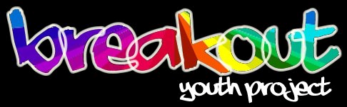
Referral/Induction Form

Date of referral:
Referred by: | Self Organisation Family Friend Other  If organisation, which:
Referrers contact details:
Young person’s name:
Young person’s date of birth: |  | Age:
Young person’s address:
Email address:
Young person’s contact numbers: | Home:  Mobile:
Ethnicity:
Which educational establishment (if any?)
How would you describe your sexual orientation?:
Gender identity:

What is the best way for us to contact you and what time of day?
Can we?
Leave a message on the telephone numbers you have given? |  | Identify ourselves to parents/carers/partner etc on phone?
Email you? |  | Write to you at your home address?
Text your mobile number?

Is the young person out? | Family
 | Friends
 | School/College/Uni/Work
 | Other (please specify)

You will need to complete an initial assessment with a youth worker, please tick your preference:
Face to face Over the phone

Which group(s) do you wish to attend- (please highlight):

Southampton | Basingstoke | Isle of Wight | Eastleigh
11-21 Group (Weekly) | 11-21 Group (Fortnightly) | 11-21 Group (Fortnightly) | 11-21 Group (Fortnightly)
1:1 Support | Gender Identity group (monthly) | 1:1 Support
SOCO Music Group  (fortnightly) | SOCO Music Group  (fortnightly) | 7-11 Breakout and Buddies group (Fortnightly)
Gender Identity Group (Monthly)

Why would you like to join Breakout?

Who should we contact if an emergency happens while you are with us?
Person’s name
Their relationship to you
Their address
Postcode
House phone
Mobile phone
Work phone

Please remember that you will need to let this person know you are a member of Breakout, in case we have to call them in an emergency.

Do you have any other support needs?

Do you have other workers supporting you?
role of worker | their name, organisation and any contact details | Your permission to contact this worker?*
* Please put your signature next to any worker you are willing for us to contact. We will only do so if an urgent need arises.

Please tell us about any medical or medication (ie its name, any side effects) information we should know & what you’d like us to do if you have a crisis while at the group.

